A MINI PROJECT REPORT
ON
“DIABETES PREDICTION using MACHINE learning”

Submitted in partial fulfillment of the requirements for the award of degree in Master of Technology (AI) 2nd Semester Examination under Nielit Deem’s to be University in the academic Jan 2025 to June 2025

Submitted by:

Heisnam Kavit Singh
(Regd No NDU202400083/2024

Under the guidance of
Dr. Usham Sanjota Chanu
(Assistant Professor, NIELIT Imphal)

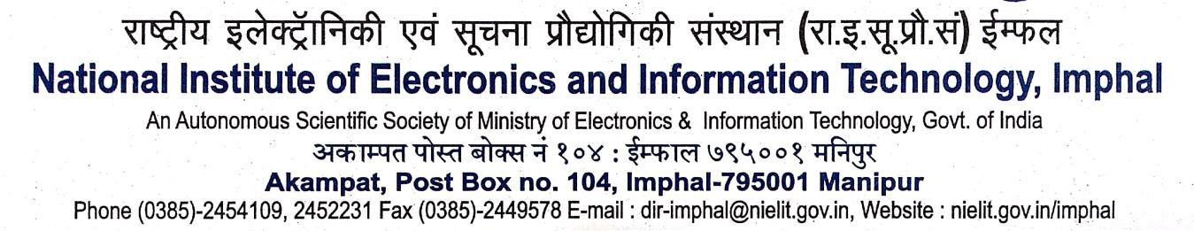
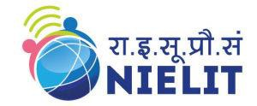

Certificate
This is to certify that the project work entitled “Diabetes Prediction using Machine Learning” is the comprehensive work done by Heisnam Kavit Singh, bearing Roll No. NDU202400083 at National Institute of Electronics and Information Technology (NIELIT) Imphal, AKAMPAT under the guidance and supervision of Dr. Usham Sanjota Chanu, Assistant Professor, as Internal Guide for the partial fulfillment of the requirements for the award of degree in Master of Technology(AI) in the Academic session Jan 2025 to June 2025.

This project is the bonafide work carried out by them. It has neither been published in any journal nor submitted in any academic institution before. This project is truly authentic and original.

Date: (Dr. Yumnam Jayanta Singh)
Place: Executive Director
NIELIT Imphal

Certificate
This is to certify that the project work entitled “Diabetes Prediction using Machine Learning” is the comprehensive work done by Heisnam Kavit Singh, bearing Roll No. NDU202400083 at National Institute of Electronics and Information Technology (NIELIT) Imphal, AKAMPAT under the guidance and supervision of Dr. Usham Sanjota Chanu, Assistant Professor, as Internal Guide for the partial fulfillment of the requirements for the award of degree in Master of Technology (AI) in the Academic session Jan 2025 to June 2025.

This project is the bonafide work carried out by them. It has neither been published in any journal nor submitted in any academic institution before. This project is truly authentic and original.

Date: (Dr. Usham Sanjota Chanu)
Place: Assistant Professor
NIELIT Imphal

DECLARATION
I hereby declare that the project work entitled “Diabetes Prediction using Machine Learning” is an authentic work developed by me at NIELIT, Imphal under the guidance and supervision of Usham Sanjota Chanu, Assistant Professor, NIELIT IMPHAL for the partial fulfillment of the requirements for the award of degree in Master of Technology (AI), under the Nielit Deem’s to be University in the Academic session Jan 2025 to June 2025.

I also declare that all contents incorporated in this report has not been submitted in any form for the award of any other degree or diploma of any other Institutions or University.

Date: ....................... Signature of the Student
Place: ...................... (Regn.No. NDU202400083 /2024)

ACKNOWLEDGEMENT
I have taken efforts in this project. However, it would not have been possible without the kind support and help of many individuals and the institute. I would like to extend my sincere thanks to all of them.
I am highly thankful to my supervisor Usham Sanjota Chanu, Assistant Professor, NIELIT, Imphal for her guidance, constant supervision and for providing necessary information regarding the project and for conducting weekly progress review kept me going. I would like to express our gratitude towards my parents & faculty members of the institute for their kind co-operation and encouragement which helped me in completion of this project.

My thanks and appreciations also go to my friends in developing the project and people who have willingly helped me out with their abilities.

Date: ......./......../....... Signature of the Student
Place: ...................... (Regn.No. NDU202400083 /2024

Abstract
This project work entitled "Diabetes Prediction using Machine Learning" has been carried out as a 2nd semester project for the partial fulfilment of the requirements of the MTech-AI course.
This research explores the application of multiple machine learning algorithms for predicting diabetes risk using patient health data. We implemented and compared four widely-used algorithms: K-Nearest Neighbors (KNN), Naive Bayes, Random Forest, and Logistic Regression.
A dataset of 768 individuals with various health metrics was utilized. The data was pre-processed and split into training (80%) and testing (20%) sets. Each algorithm was trained and evaluated using standard performance metrics including accuracy, precision, recall, and F1-score.
Results showed that Naive Bayes outperformed other algorithms, achieving the highest accuracy of [77%]. KNN and Logistic Regression followed with accuracies of [75%] and [76 %] respectively. While the Random Forest model provided easily interpretable rules, it showed lower accuracy at [74%].
This comparative analysis demonstrates the effectiveness of different machine learning approaches in diabetes risk assessment. The findings suggest potential for developing robust predictive tools to aid in early diagnosis and intervention strategies for diabetes management.

CONTENTS
CHAPTERS PAGES
1. INTRODUCTION 1-3
1.1 INTRODUCTION
1.2 OBJECTIVE
2. LITERATURE SURVEY 4-7
2.1 LITERATURE REVIEW
2.2 MERITS OF THE PROPOSED SYSTEM
3. METHODOLOGY 8-26
3.1 METHODOLOGY
3.1.1 SUPERVISED LEARNING
3.1.2 UNSUPERVISED LEARNING
3.1.3 REINFORCEMENT LEARNING
3.2 K-NEAREST NEIGHBORS (KNN)
3.3 NAÏVE BAYES.
3.4 RANDOM FOREST
3.5 LOGISTIC REGRESSION
4. SYSTEM DEVELOPMENT 27-38
4.1 FLOWCHART
4.2 SYSTEM ARCHITECTURE
4.3 PROGRAMMING LANGUAGE USED
4.4 IMPORTED LIBRARIES
4.5 TECHNICAL REQUIREMENT
4.5.1 HARDWARE REQUIREMENT
4.5.2 SOFTWARE REQUIREMENT
5. IMPLEMENTATION OF MODEL 39-47
5.1 DATASET USED
5.2 DATA PREPROCESSING
5.3 MODEL FITTING
5.4 DATA MANIPULATING
5.5 VARIOUS STAGES OF THE PROJECT
5.6 DATA VISUALIZATION
5.7 IMPLEMENTATION
6. RESULTS AND DISCUSSION 48-51
7. CONCLUSION 52-54
7.1 FUTURE SCOPE
7.2 CONCLUSION
REFRENCES 55

